RIVERSLEY PARK
A Tour of the Park and Timeline
By Peter Lee

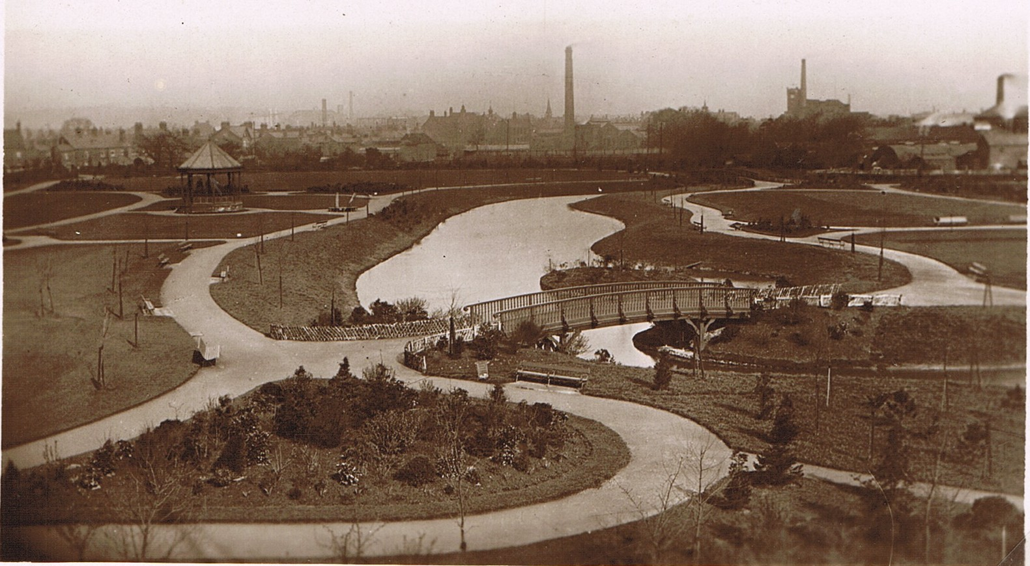
The Park newly laid out, c. 1907 possibly not open to the public in this view. The photograph was taken from the railway embankment of the Nuneaton to Coventry railway line. Note all the new planting. 2011, 104 years later, trees that have now grown to maturity. The bridge in the foreground has been replaced twice. The original timber bridges, provided originally, rotted away in time. The one in the foreground was replaced with a new bridge later, but this got damaged in an air raid during World War II and was replaced by a modern steel and concrete bridge. On the skyline we can see the town of Nuneaton with tall chimney’s designating former town businesses. The tallest one immediately to the right of centre is Nuneaton Electricity Works then owned by Nuneaton Borough Council. The distinctive outline of Nuneaton Flour Mill to its right. The chimney on the extreme right may be at Nuneaton Timber yard.

Origin of the names:

RIVERSLEY PARK. The land the park was built on (13 acres) was donated by Edward Ferdinand Melly (1857-1941); managing director of Griff Collieries, whose family home was called “Riversley”, at Aigsburth, Liverpool. On 16th January 1907 Mr. Melly gave the land and £500 to plant and lay out the park. The new public amenity officially opened on 6th July 1907. It was a very auspicious occasion because it marked both Mr. Melly’s 50th birthday and the incorporation of Nuneaton as a Borough. 3000 local people attended the opening. On 29th April 1907 Ald. Melly was given the “Freedom of the Borough”. On opening day the Nuneaton Town Band entertained residents at 6d per head, the children attended at half price. Mr. Melly also donated £600 towards the cost of the Nuneaton Museum and Art Gallery which commenced being built in 1914 and was completed in 1917

Park superintendents:
Jim Hannaby in the 1930’s & 40’s
Joseph William Worthington (until he retired in 1954)

THE PINGLES. Pingles is an old English word meaning a small area of enclosed land or a water meadow. 28 acres.

MILL GARDENS. Named after the old Flour Mill. Now known as the George Eliot Memorial Gardens. 1½ acres. Incorporates the Garden of Memory.

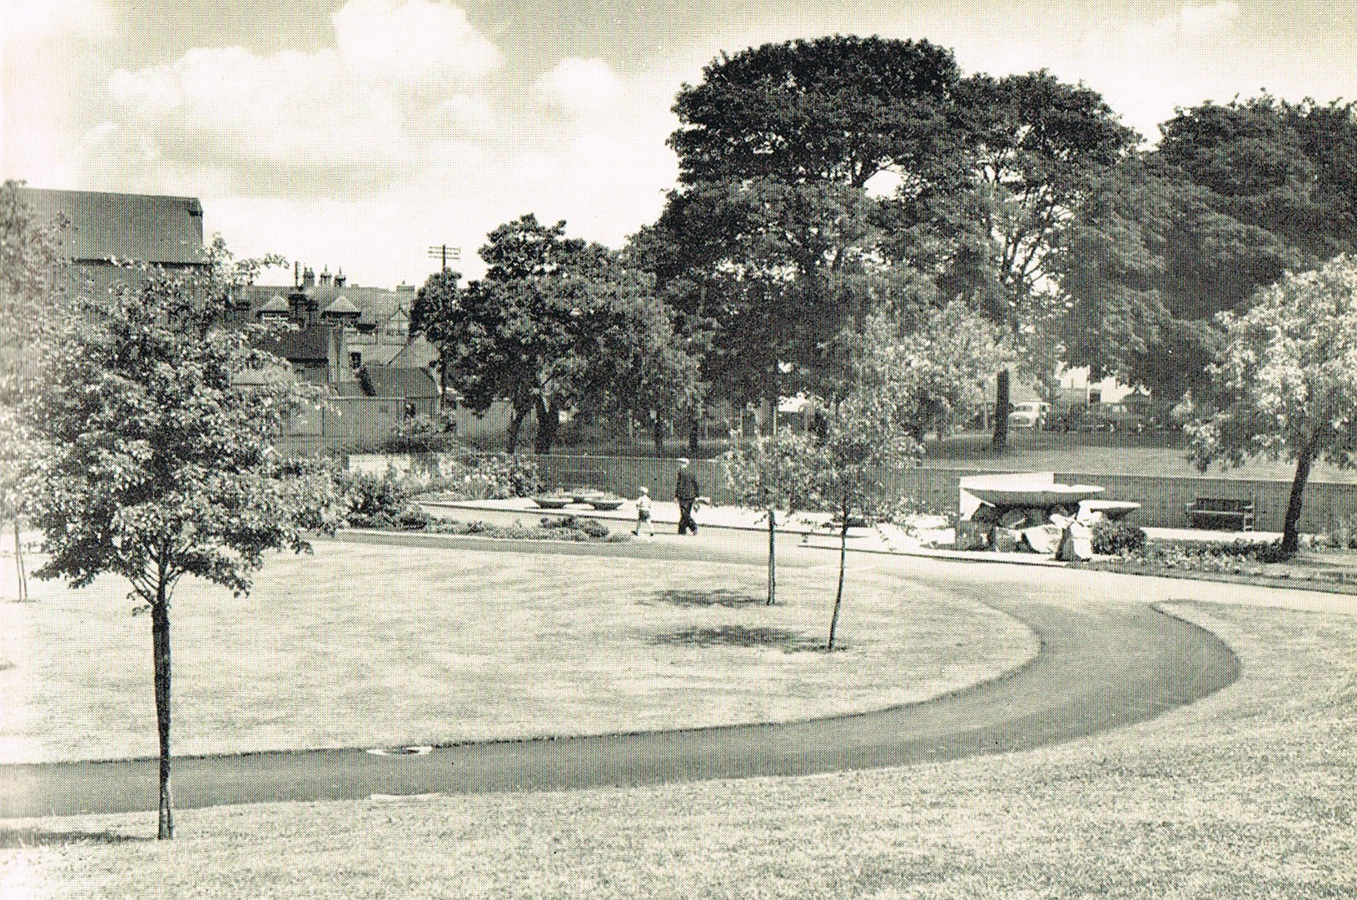
George Eliot Gardens as newly laid out in 1953.

THE RESERVOIR GARDENS. Surrounding the mill header pool.

Chronology:

Prior to the park being opened the area of land it now encompasses was open water meadows and fields leading down to the River Anker. Nuneaton was a very watery town with a propensity for flooding so there was little incentive to build close to the river at this point. The land was farmland until the park opened in 1907. Part of the site had been used as a municipal rubbish tip and occasionally when the park has been trenched for services to be laid parts of the tip are exposed revealing old bottles, leather shoes, rotten wood and other detritus from the 19th century. The full extent of the waste area is not known.

Before 1900 it was very much as it had been before for centuries. The boundary of the old parishes of Chilvers Coton and Nuneaton ran along the River Anker so the park now lies in both parishes. The junction of the River Anker with the Wash Brook in Mill Walk was the farthest of extremity of Chilvers Coton and this part of Coton was known as “Town End”. (there were four ends of Chilvers Coton – Town End, Church End (now Avenue Road), Virgins End (where College Street meets Coventry Road) and Heath End which was the area encompassing Heath End Road to the dark woods of Arbury.

At the town end of the park the water mill was a dominant feature. It was much different at the beginning of the 19th century than as it we remember it up until the 1970’s. The old mill was built on an island in effect and the course of the river much altered to that we know today. One side of the island was a mill race and a large water wheel fitted. Later on, after the old mill caught fire and burnt down, a new modern blue brick mill was erected.

Next to Sainsbury’s car park is a pond with an island in the centre. This was a header pool for the mill, so that during the summer when the river was at a low ebb, when the miller needed more power to his water wheel he could open a penstock and allow some water out of the pond to top up the flow through the wheel. It was also stocked with fish which could be caught for the table.

Edward Ferdinand Melly was the son of Charles Pierre Melly (1829-1888) of Riversley. Melly senior was an eminent Liverpool citizen, promoter of drinking fountains at a period when fresh drinking water was not universally available. Melly junior also installed a drinking fountain in Nuneaton town centre shortly after his arrival in town. Charles Melly organised the purchase of and laying out of Sefton Park, Liverpool. Edward Melly gave the park to Nuneaton. . He lived in a large house called “the Close” which stood roughly where the inner ring road cuts through past Sainsbury’s. Edward Melly died with his wife when his home was bombed in the Blitz on Nuneaton on the night of 16th/17th May 1941. After the war his house was cleared away together with a row of blitz damaged properties in Church Street which included “Lawyer Dempster’s House”. These houses backed on to Mill Gardens. But, of course, Mill Gardens did not exist then. These houses had extensive grounds which stretched down to the River. Some of the old trees from their gardens survived and were incorporated within Mill Gardens.

A big alteration to the area we know as the Park and the Pingle Fields occurred when the Coventry to Nuneaton railway was built and opened in 1850. In order to gain height and clear the Nuneaton Ridge at Chilvers Coton the line had to be built on an embankment. This has been a feature for 161 years since then. In the old steam days it was quite a sight to see the old steam engine’s charging the bank up to Coton station, particularly with a full coal train, because the gradient made these old steamers work very hard with a magnificent plume of steam and a cacophony of sound which varied a great deal with the type of loco employed. The old London & North Western steamers were great exponents of the Pingles fireworks show, particularly the Super ‘D’ s whose performance included a large amount of wheezing, clanking, and fizzing, with steam issuing from every orifice, and was a sight to behold. Especially in the dusk of an evening, when the crew could be seen silhouetted in the cab by the glow of the fire, as their engine got slower and slower and more asthmatic. The bank today, now climbed by diesel engines, no longer provides the entertainment of the old steam days. The embankment is penetrated in several places by bridges and tunnels. One carries the railway over the River Anker, another tunnel is a familiar entry point to the Pingle Fields, and there is another smaller tunnel further along which does the same thing. We are always familiar with the magnificent bridge which is Coton Arches. Now one of the oldest structures in Nuneaton built from Chilvers Coton bricks and the construction is a testimony to George Wykes the bricklayer whose unseen but brilliant skills featured in this outstanding piece of Victorian engineering.

In the Park and round about:

1086 A mill in Nuneaton is first mentioned in the Domesday Book.

1816 A steam engine was erected at Nuneaton Flour Mill.

1837 A property known as “Councillors Yard” was demolished belonging to Charles Nutt (1776-1823). A new house was erected for Thomas Robinson (1787-1940) called “The Close”. Later owned by Joseph Fielding Johnson, followed by Edward Melly.

1844 The bed of the river Anker was lowered by 3’0” to get a more powerful head of water for the flour mill. Thomas Hollick took over at Nuneaton flour mill. Thomas Hollick died in 1868 when John Knowles purchased the business.

1863 A new steam engine by James Watt & Co. London & Soho. Erected at Nuneaton Flour Mill

1864 The Nuneaton Wool & Leather Company established by Joseph Fielding Johnson (1840-1917). Fielding Johnson’s, a Leicester business started there in 1720 was a separate company owned by Joseph Fielding Johnson’s family. The Fielding-Johnson’s were related to the Earls of Denbigh.

1868 John Knowles purchased Nuneaton Flour Mill.

1879 Nuneaton Flour mill produced enough flour per week to support 676,000 people for 12 months.

1882 Edward Melly, a mining engineer, came to Nuneaton to participate in the development of Griff Collieries.

May 15th 1885 Nuneaton Flour Mill burnt to the ground. There were 14 pairs of stones in the old water mill.

September 23rd 1885 Foundation stone for new mill was laid. Architect for mill was Throop of Seething Lane, London.
Milling plant supplied by Thomas Robinson of Rochdale.
Steam engine plant supplied by W & J Galloway & Sons
Each floor was fitted with a “Simplex” fire extinguisher

September 24th 1886 New five storey blue brick mill started production.

1888 Joseph Fielding Johnson sold the Close when he moved into Attleborough Hall on marriage to his second wife – Patty Townsend. Mr. Fielding Johnson was the first mayor of Nuneaton in 1907 and a director of several other local businesses such as Stanley Brothers and Parsons & Sherwin’s.

1902 New municipally owned electricity generating station opened.
16th January 1907 The land for the park was given by Mr. Melly.

6th July 1907 Park opened to the public.
1913 First proposal to build Nuneaton Museum.

1917 Nuneaton Museum opened. A temporary war memorial was erected in May 1918 but this was later taken down and replaced by one in the Park. At the end of World War 1, 675 Nuneaton men had died in war service.

14th November 1920 the war memorial was opened in the Park near the museum.

1919 Nuneaton Rugby Club leased the field at the back of the New Inn opposite the Albion buildings in Attleborough Road. This became the Harry Cleaver Ground. (Harry Cleaver was the proprietor of Nuneaton Timber Co. and later Yoxalls, the well known café in Abbey Street.

1919 Nuneaton Wool & Leather incorporated as a limited company.

21st December 1921 Nuneaton Midland Red Bus Garage in Coton Road opened. It was extended in 1925.

May 1923, Monty Moreton whose bus garage backed onto Pingle Fields first started his business with a swap bodied bus. (removable bus and lorry body).

1928 New Riversley Park Clinic proposed and completed by 1929.

1930 Riversley Park extended into an area of land adjacent to Home Park Road.

1931 Nuneaton Wool & Leather Ltd was wound up. It proved a temporary closure.

1932 Swinnerton School was opened named after Mr. R.W.Swinnerton (1848-1939).

On 22nd May 1932 The Great Flood of Nuneaton occurred which rose within one hour to a maximum of five feet in the Market Place. The river flooded the Park to a considerable depth.

1933 Nuneaton Wool & Leather Ltd was taken over by Charles Reginald Jordan and business resumed.
New methods of manufacture at The Union Wool & Leather Co. Ltd was introduced to produce furs, sheepskin, using skins from Australia, New Zealand, South Africa and South America. The company turned the material into boot and shoe linings, gloves or pads for cushioning and polishing. Bedroom slippers, toys, powder puffs etc.

In 1936 The New catholic church was built in Coton Road.

7th May 1937 there were celebrations in the Park to mark the Coronation of King George VI. Despite heavy rain there was a large turn out for the celebrations. A special stand was erected and the broadcast from Westminster Abbey was relayed from speakers in the stand to the gathered crowd.

(A well known park keeper in the 1930’s and 40 was James (Jim) Hannaby)

7th May 1945 VE day celebrations in the park.

4th June 1948 Field Marshall Bernard Montgomery K.G. G.C.B. D.S.O unveiled the memorial to the fallen Nuneaton men of World War 2.

In 1951 The obelisk which had stood as a memorial to George Eliot and erected by Sir Francis Newdigate-Newdegate G.C.M.G a former governor of Tasmania and Western Australia was removed from Arbury Park to the Mill Gardens.

On 1st May 1952 The George Eliot Memorial Garden was opened by the Mayor of Nuneaton, Ald. W.S.Johnson. Three Almond trees from Jerusalem had been planted, given by the Government of Israel as well as 200 shrubs and trees. The garden covers 1½ acres.
The garden was designed as the result of a national competition and the award went to Miss Mary Breandle B.A. Dip. Hort. And Mr. Ronald Sims A.R.I.B.A., A.A.Dipl.

On 16th May 1953 the Garden of Memory opened in Riversley Park.

1954 Joseph William Worthington, Nuneaton Parks Superintendent, retired.

1959 The Boer War Memorial was moved from Bond Gate to the Park. Later stolen but replaced after a vigorous local campaign.

1959 Nuneaton flour mill finished grinding corn for human consumption. It carried on as a Provender Mill (animal feedstuffs).

1960 The Midland Red Bus Garage was demolished (having closed May 1960)

1963 Foundations laid for new swimming baths in the Pingles.

1965 The Pingles swimming baths opened in Avenue Road.

October 1970 Nuneaton flour mill finally ceased production.

1973 Nuneaton flour mill was demolished.

1974 Work started to demolish houses in Coton Road on the park side and turn it into a dual carriageway.

1976 The River Anker flood relief scheme brought into use which diverted water away from the centre of Nuneaton and virtually eliminated local flooding. There had been serious flooding in the town virtually every 10 years before then, and every thirty years or so very large parts of the town centre was flooded.

1981 George, The Peacock, who resided in the Park Aviary died.

1982 North Warwickshire Railway Society installed a short 2’0” gauge railway in the Pingle fields. The rolling stock came from the Burton Latimer quarries of Thomas E. Gray Ltd in Northamptonshire.

1986 Union Wool & Leather works demolished to make way for Sainsbury’s store. Last owner was Shearlings International.

1987 Sainsbury’s store opened on site of former Union Wool & Leather works.

1994 The former “Harry Cleaver Ground” sold for housing. Ribbonfields built over the site.

July 1994 Monty Moreton, the bus company, whose depot backed on to the Pingle Fields went out of business.

1996 The Peace Avenue dedicated in the Park. A plaque was installed.

1996 New barriers installed in the park to prevent bank erosion.

14th June 1997 The narrow gauge line of the North Warwickshire Railway Society ceased operations and was dismantled to make way for a new sports ground and running track. The track and rolling stock was dispersed.

2002 The aviary, which was dilapidated by this time, was demolished.

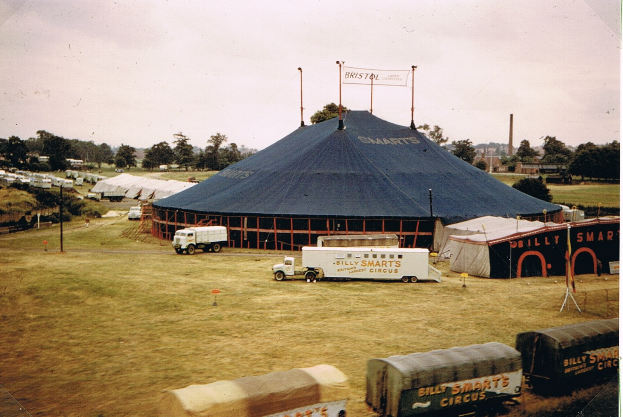
A familiar sight in the Pingles for many years – Billy Smart’s Circus. A photo taken from a moving train on the Coventry to Nuneaton line. The Wem Brook on the left.
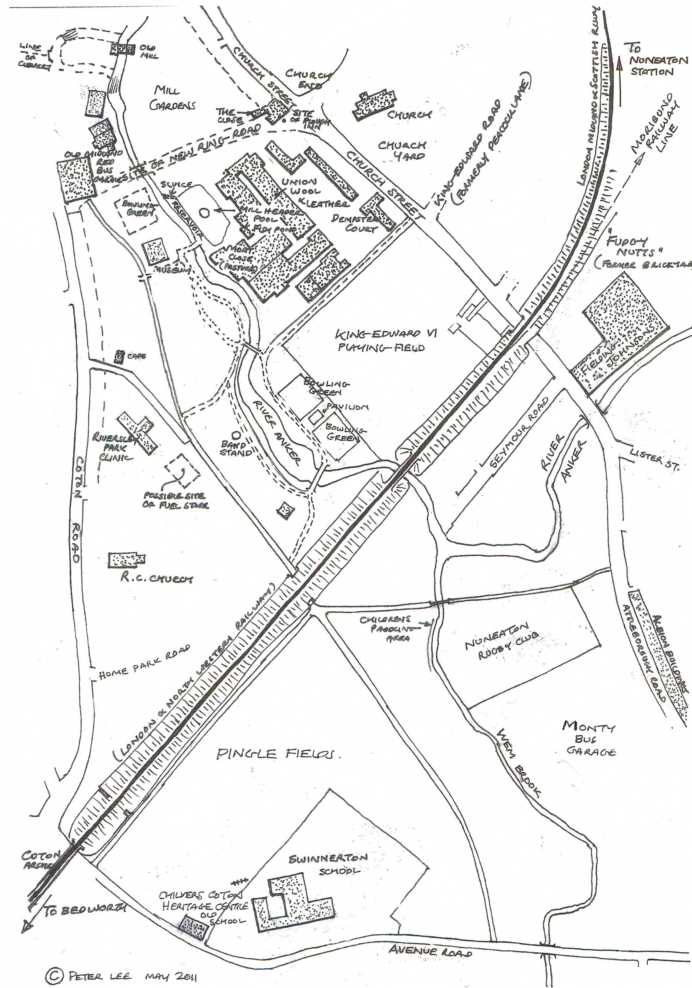
A sketch map showing where things used to be. Some that are still there. Others features long since gone.

